Workshop CURACAO

Small Islands, Big Solutions: Innovative Education for Climate Action in the Caribbean

Teacher: Carlo Cijntje, geography teacher at Radulphus College

Date: March 4th, 2026
Duration: 120 minutes
Audience: Teachers from Turkey, Madeira, Crete, Rumania, Martinique and Curaçao participating in an Eramus+ exchange with educators from the Caribbean.
Focus: The environmental challenges of the Caribbean, specifically Curaçao, and how schools can empower students to become environmental change-makers.
UN Sustainable Development Goals (SDGs):
- SDG 12 – Responsible Consumption and Production
- SDG 13 – Climate Action
- SDG 14 – Life Below Water
- SDG 15 – Life on Land

Workshop Objectives
By the end of the workshop, teachers will:
- Understand the unique environmental vulnerabilities of small island states such as Curaçao.
- Experience innovative educational approaches that combine science, sustainability, and student action.
- Develop classroom projects that connect local Caribbean issues to global sustainability challenges.
- Learn how students can become citizen scientists and contribute to real environmental solutions.

Why Curaçao?
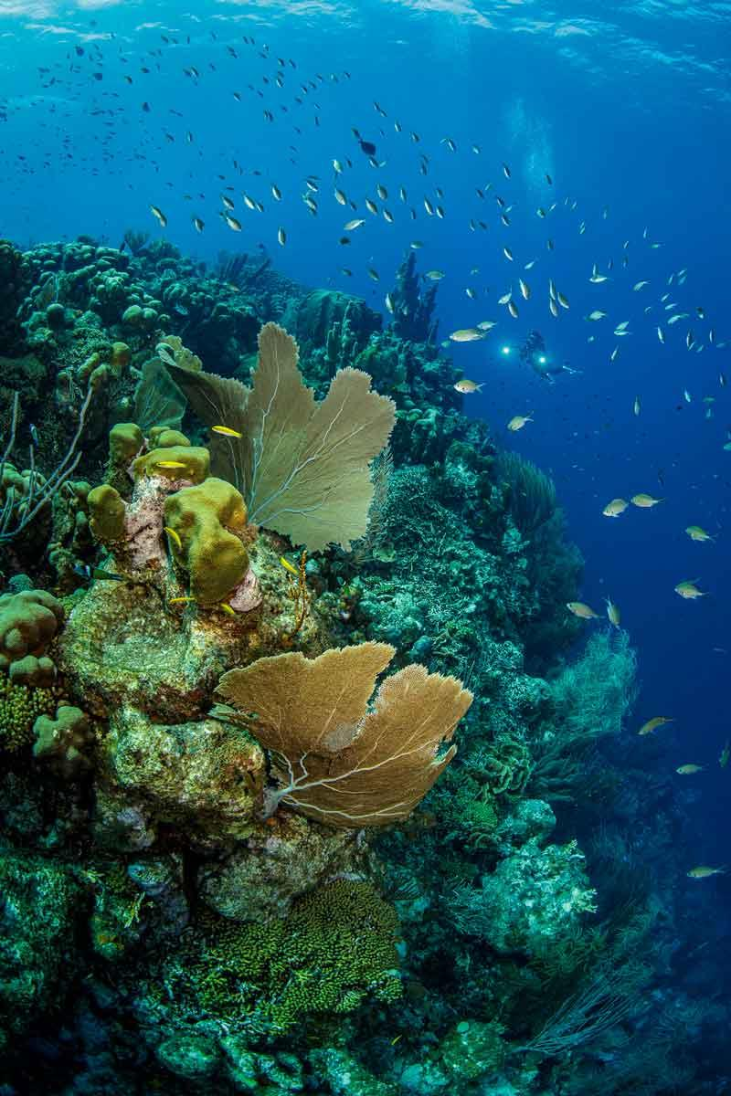
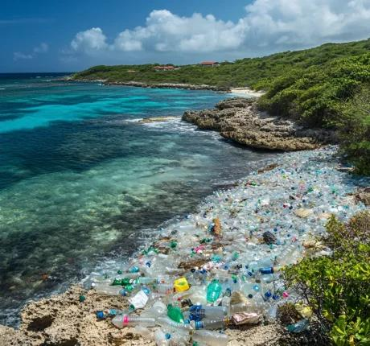
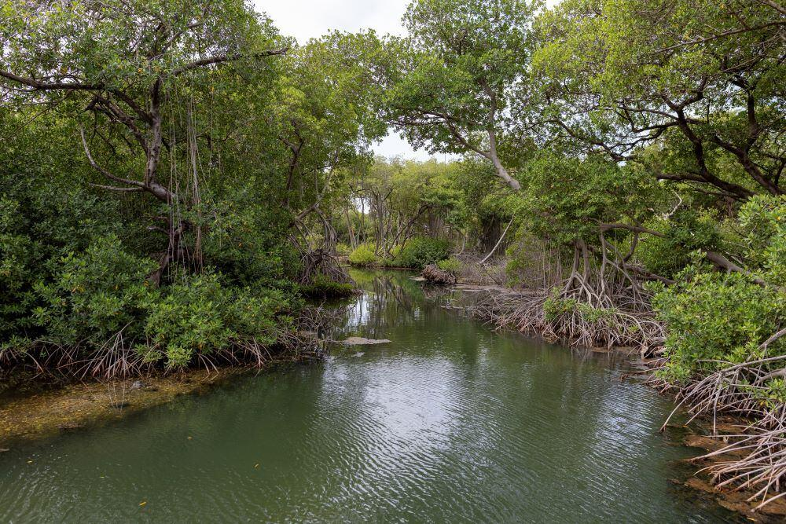
8
Curaçao faces several interconnected environmental challenges:

Climate Change
- Longer drought periods
- Increasing temperatures
- Coral bleaching
- Rising sea levels threatening coastal areas

Waste Management
- Plastic pollution entering the Caribbean Sea
- Illegal dumping sites
- Limited landfill space on small islands

Biodiversity Loss
- Decline of coral reefs
- Loss of mangroves
- Threats to sea turtles and native bird species
- Invasive species affecting local ecosystems

Workshop Programme (60 Minutes)

1. Opening Activity – "An Island Under Pressure" (10 minutes)

Materials:
- Large map of Curaçao
- Photos of environmental problems
- Sticky notes
Participants work in pairs and place images on the map:
- Coral bleaching
- Plastic pollution
- Drought
- Coastal erosion
- Mangrove destruction

Reflection Questions:
- Why are small islands more vulnerable to climate change?
- How do these problems affect tourism, food security, and people's livelihoods?
Key Message: On a small island, environmental problems are interconnected and immediately impact communities.

2. Mini Presentation – The Caribbean Reality (10 minutes)

Climate Change in Curaçao
- Average temperatures are increasing.
- More frequent periods of drought affect agriculture and water availability.
- Coral reefs are suffering from warmer sea temperatures.

Waste Management
- An estimated large proportion of marine litter originates from single-use plastics.
- Ocean currents bring additional plastic waste from other countries to Caribbean shores.

Biodiversity Loss
- Mangroves serve as nurseries for fish and protection against coastal erosion.
- Coral reefs support fisheries and tourism.
- Pollinator populations are declining.

3. Innovative Learning Stations (20 minutes)
Participants rotate through four stations.

Station 1 – Climate Detectives: Measuring Heat

Activity:
Participants use temperature maps of Curaçao to identify urban heat islands.

Classroom Project:
Students measure temperatures:
- In the schoolyard
- Under trees
- On asphalt
- Near the coast

Driving Question:
How can we make our schools cooler and greener?

Innovative Method:
Citizen Science + STEM.

Station 2 – Plastic Pirates of the Caribbean

Activity:
Teachers analyze samples of beach litter.

Classroom Project:
Students collect and classify waste from local beaches and determine:
- What type of waste is most common?
- Where does it come from?
- How can it be reduced?

Innovative Method:
Inquiry-Based Learning.

Station 3 – Saving the Mangroves
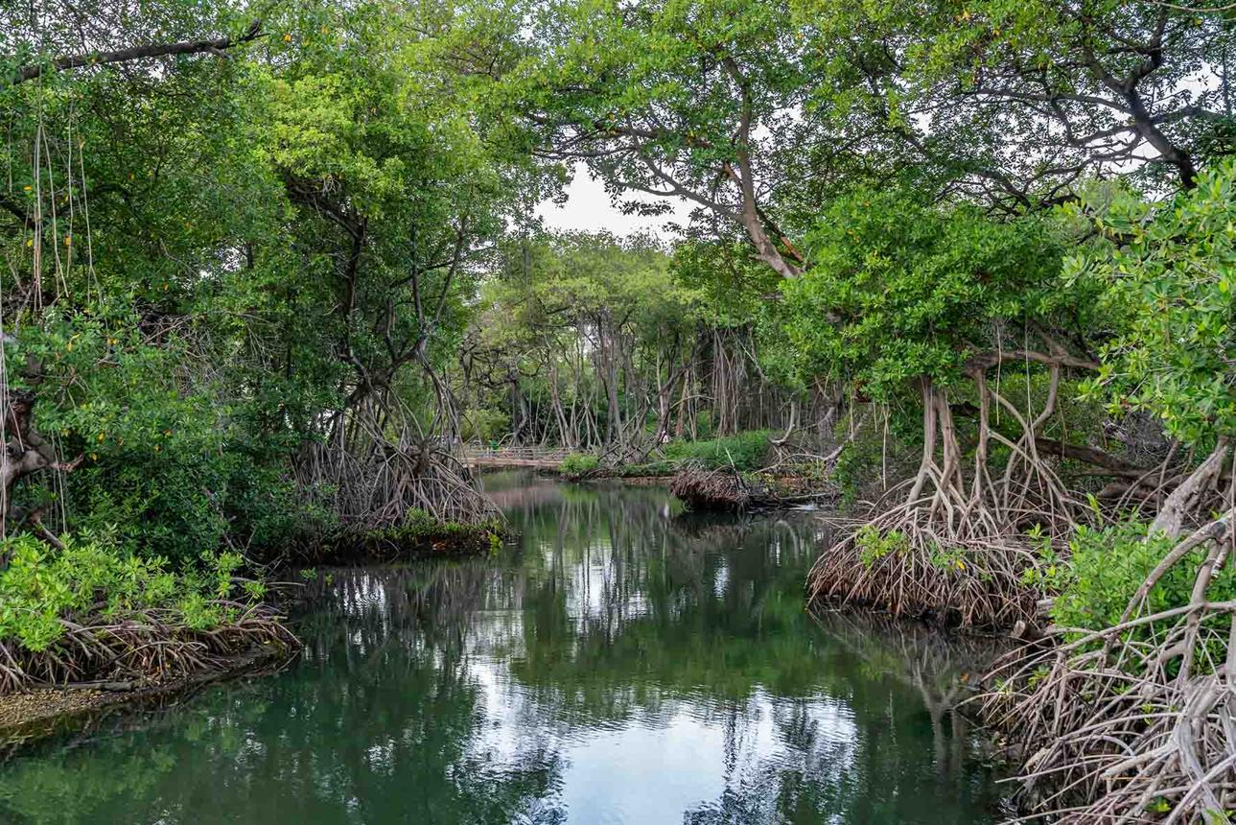
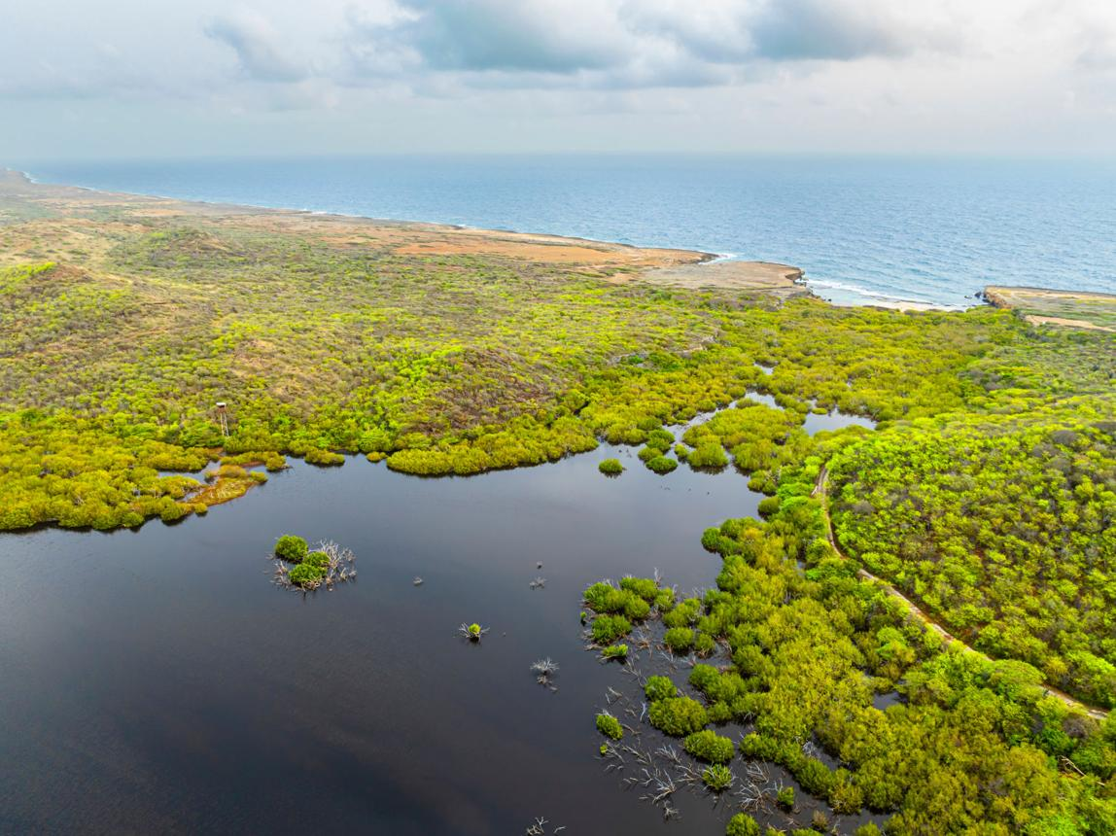
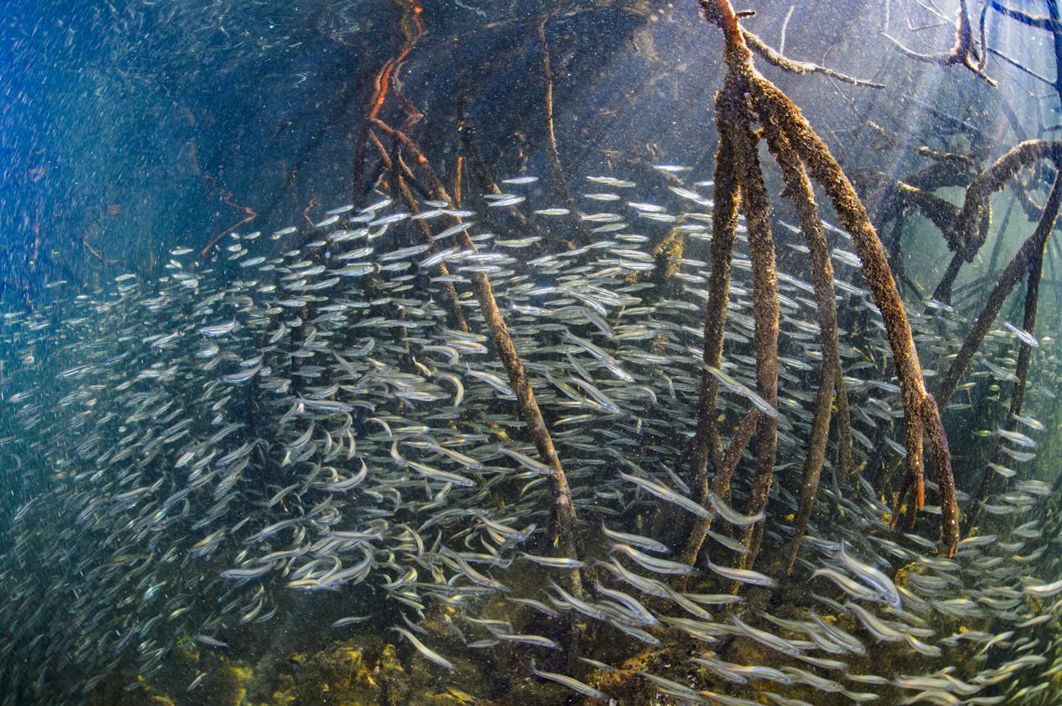
6

Activity:
Participants receive cards representing:
- Fish
- Crabs
- Birds
- Mangroves
- Tourists
They simulate what happens if mangroves disappear.

Classroom Project:
Students conduct biodiversity surveys in local mangrove areas.

Innovative Method:
Systems Thinking and Outdoor Learning.

Station 4 – Coral Reef Guardians
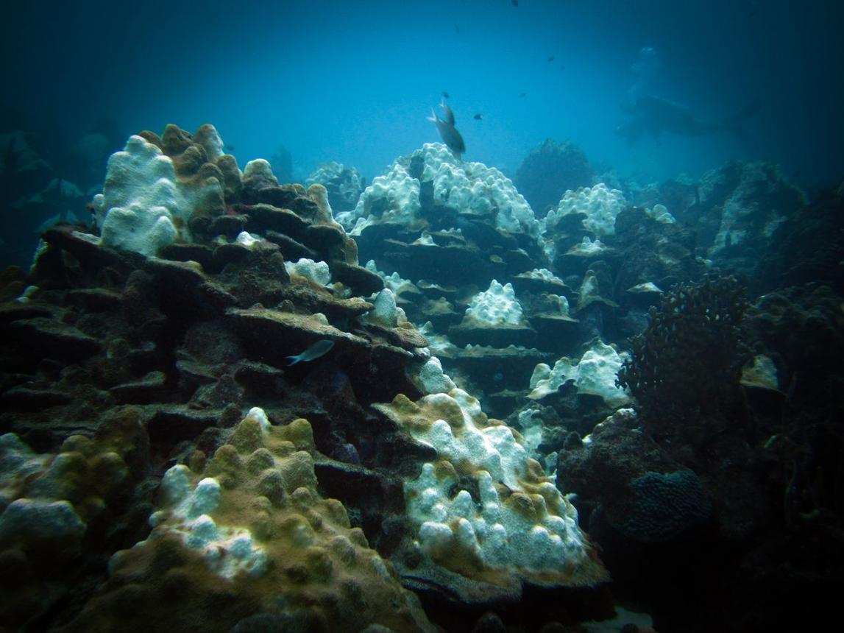
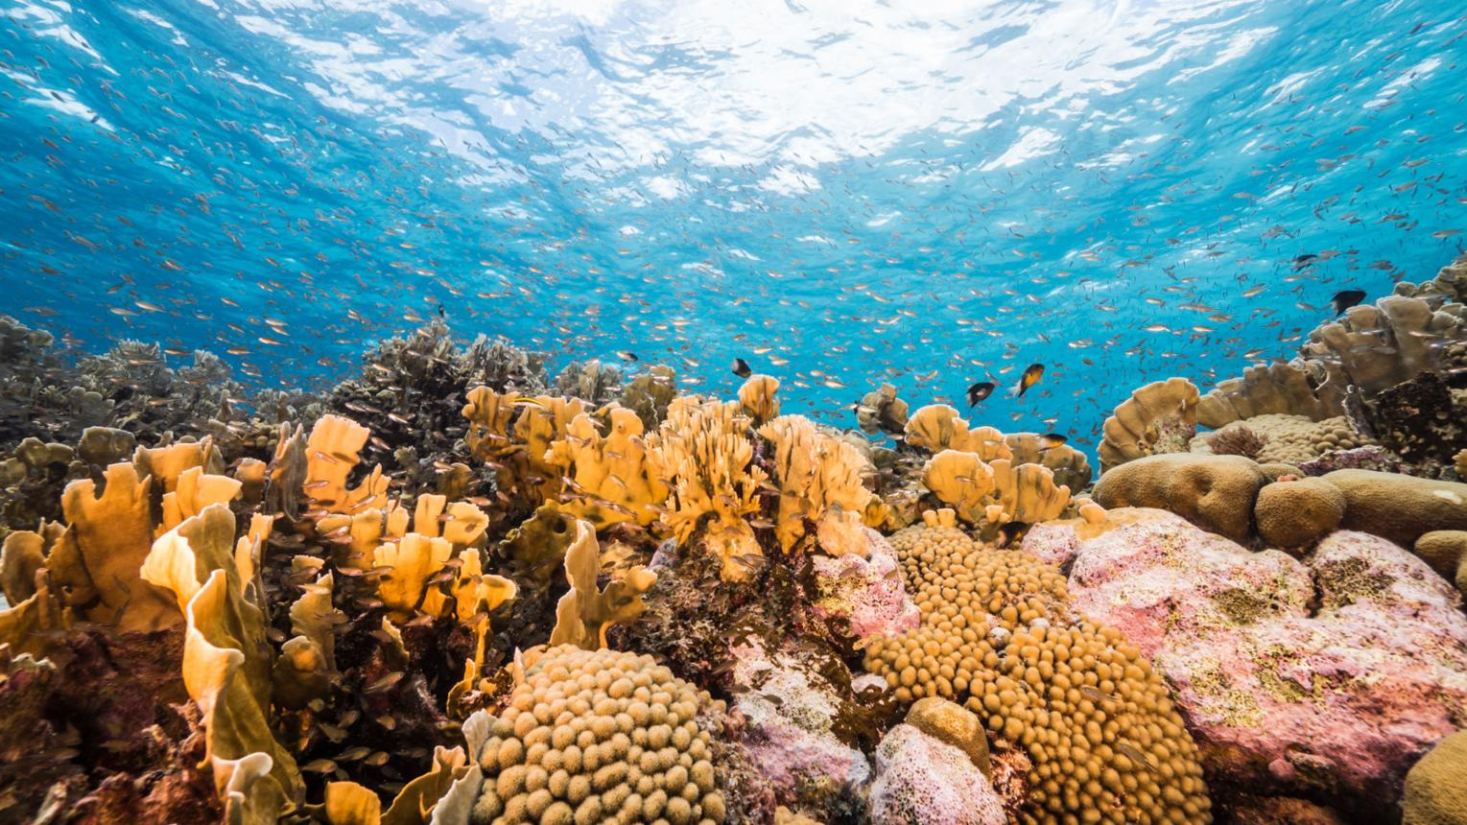
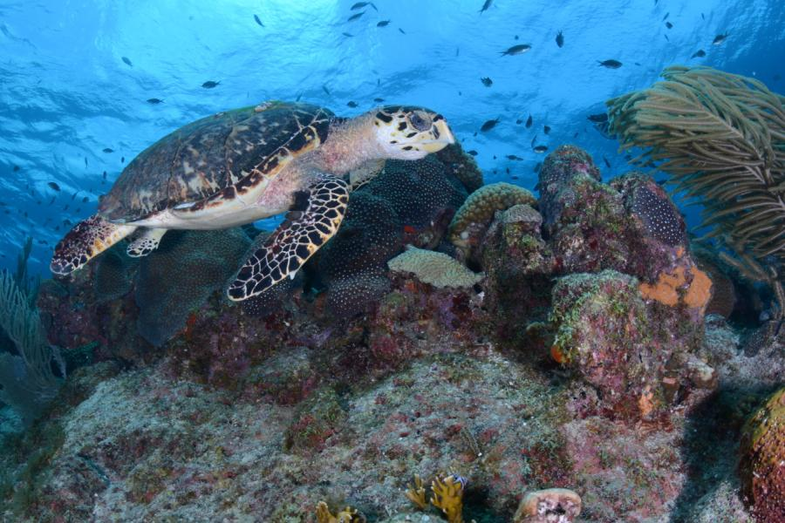
5

Activity:
Teachers compare healthy and damaged coral reef photographs.

Classroom Project:
Students create awareness campaigns:
- Reduce sunscreen pollution.
- Reduce plastic use.
- Promote responsible tourism.

Innovative Method:
Project-Based Learning and Digital Storytelling.

4. Design Challenge – "Our Island Solutions" (15 minutes)
Mixed international groups create a sustainability project.

Challenge:
Design a project that could realistically be implemented in a school in Curaçao.

Choose one issue:
- Drought
- Plastic pollution
- Biodiversity loss
- Coral degradation

Project Template:
Problem: What environmental challenge are we addressing?
Investigation: How will students gather data?
Action: What solution will students implement?
Evaluation: How will success be measured?
Sharing: How can we share our findings internationally?

Examples of Student Projects

Climate Project
Create shaded green areas and measure temperature reductions.

Waste Project
Develop a "Plastic-Free School Week."

Marine Project
Monitor beach litter and compare data with schools in Europe.

Biodiversity Project
Create a pollinator garden using native Caribbean plants.

5. Reflection and Commitment (5 minutes)
Participants write:
"One action I will implement in my school after this workshop."
Each participant hangs their commitment on a large poster of a Divi-Divi tree, the national symbol of resilience in Curaçao.

Innovative Educational Approaches Highlighted
✅ Citizen Science
✅ Outdoor Education
✅ Place-Based Learning
✅ Project-Based Learning
✅ STEAM Education
✅ Design Thinking
✅ International Collaboration Projects
✅ Student-Led Environmental Research

Closing Message
"Curaçao may be a small island, but its environmental challenges mirror those of the entire planet. By empowering our students to investigate, innovate, and act, we prepare them not only to protect our island but also to become global citizens capable of creating a more sustainable future."

